How to control the effect?
-You can adjust the Rotation at the Z-axis to change the direction of the effect.
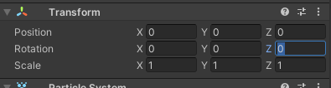
-You can use these effects for the guns to make the shoot.

